**An Inquiry into Life Expectancy and GDP**

Is wealth destiny?

I sure hope not. But, when it comes to how long we live it can seem that way. We look around ourselves and see evidence of it. For example in the United States, where I live, there is a 12 year gap in life expectancy between the rich and poor(measured for those 40 years of age). [And the trend seems to be widening](https://qz.com/1882206/the-rich-are-adding-more-years-to-their-life-than-the-poor-in-the-us/#:~:text=For%20those%20that%20were%20in,years%20greater%20than%20in%202001.). This is not to say that wealth is the only important piece in the life expectancy puzzle. Clearly, there are other factors in play and perhaps wealth is just a surface sign pointing to other causes, such as where the [poor and wealthy live](https://www.nytimes.com/interactive/2016/04/11/upshot/for-the-poor-geography-is-life-and-death.html). But, it is important.

Widening the scope and using this as a starting point for our inquiry. Can we find a link between the wealth of a nation and its life expectancy? I think we can. But first, what leads us to believe there is a gap between nations in the first place? Take a look at this list of the top [countries ranked by life expectancies](https://www.worldlifeexpectancy.com/world-life-expectancy-map).

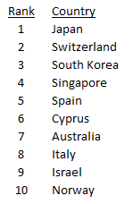

Top Ten Countries Ranked on Life Expectancy. Data Source: WHO Publish Date 2020

Pretty suggestive I think. All of these are wealthy nations in terms of GDP(Gross Domestic Product). Which is one measure by which the wealth of a nation is determined. It’s also readily available for every country.

Ok, now that we’re interested we need a few countries to find our link. We’ll explore our suspicion by using six countries varied in geography, wealth, and culture to see what we can find. This is done so that the countries will share fewer characteristics with each other. That way we can be a little bit more confident in the relationship. Countries chosen: Chile, China, Germany, Mexico, The United States of America, and Zimbabwe.

Let’s take a look at them using data from the WHO and World Bank for the years 2000–2015.

These are box plots which show how the data is distributed. In the ‘box’ lies the middle 50% of the values and outside but within the whiskers(the lines that extend out from the box) are the remaining values. The vertical line in the box is the median and the little green triangle is the average.

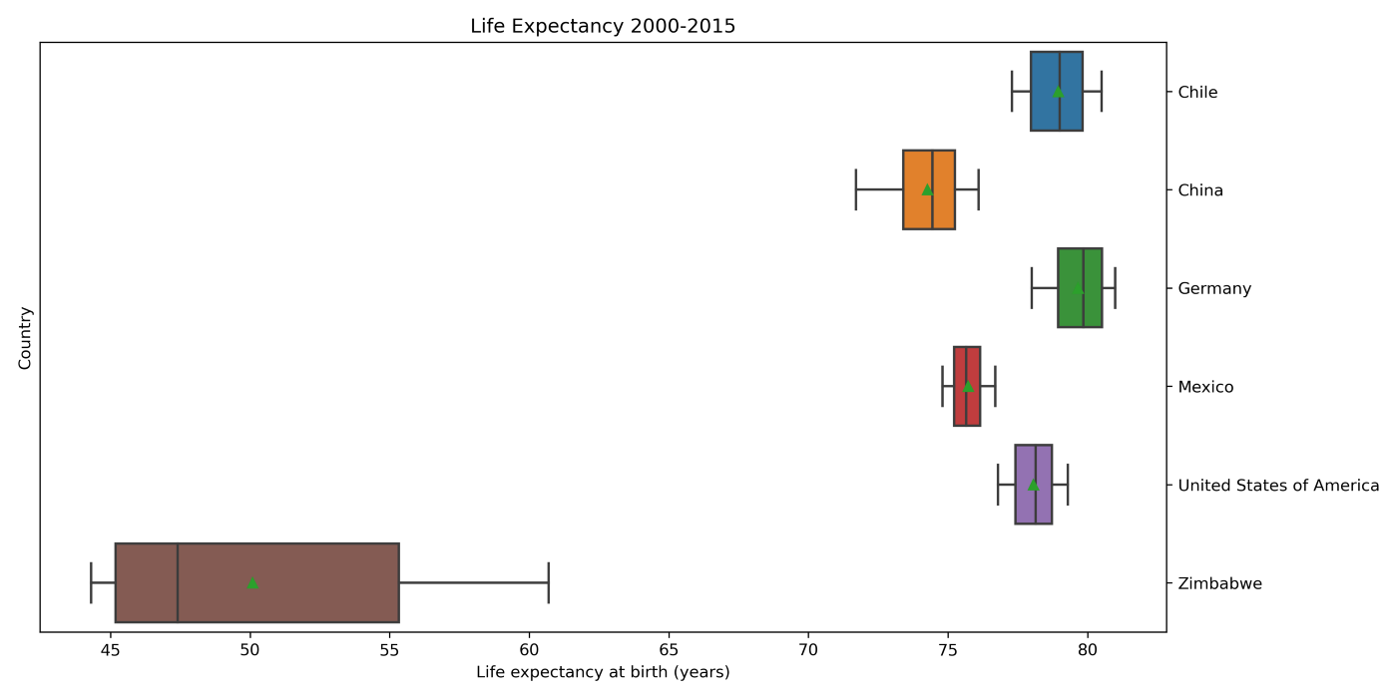

Data Source: WHO and World Bank

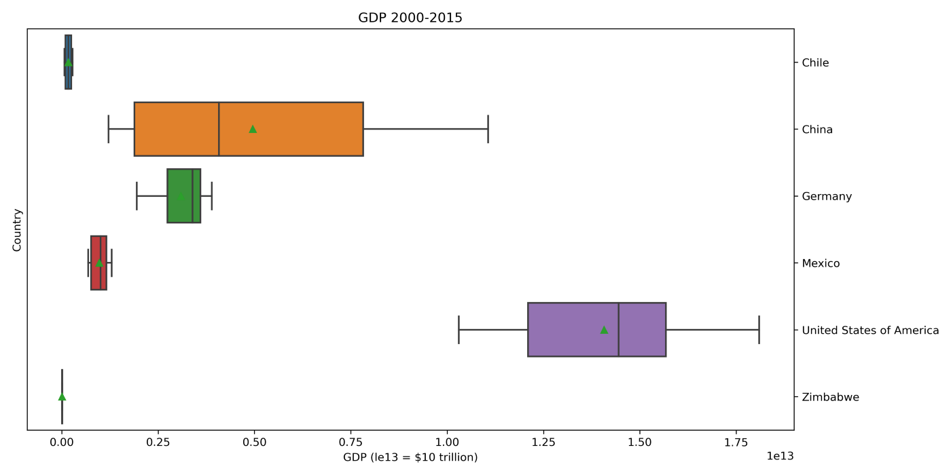

Data Source: WHO and World Bank

This is interesting. When you compare the first graph(life-expectancy) to the second graph(‘wealth’). A link isn’t so clear. Zimbabwe, the poorest nation in the group does have the lowest life expectancy. But, the United States, the richest nation in the group, is third and outdone by Chile which has 1/100th of its wealth in terms of GDP. The does not line up as we thought it might.

If the link between life expectancy and wealth between nations is hazy, can we find it comparing the country to it self?

This is a scatterplot of life expectancy vs gdp for all the countries we chose. The x-axis is in log-scale to fit all the countries on one graph.

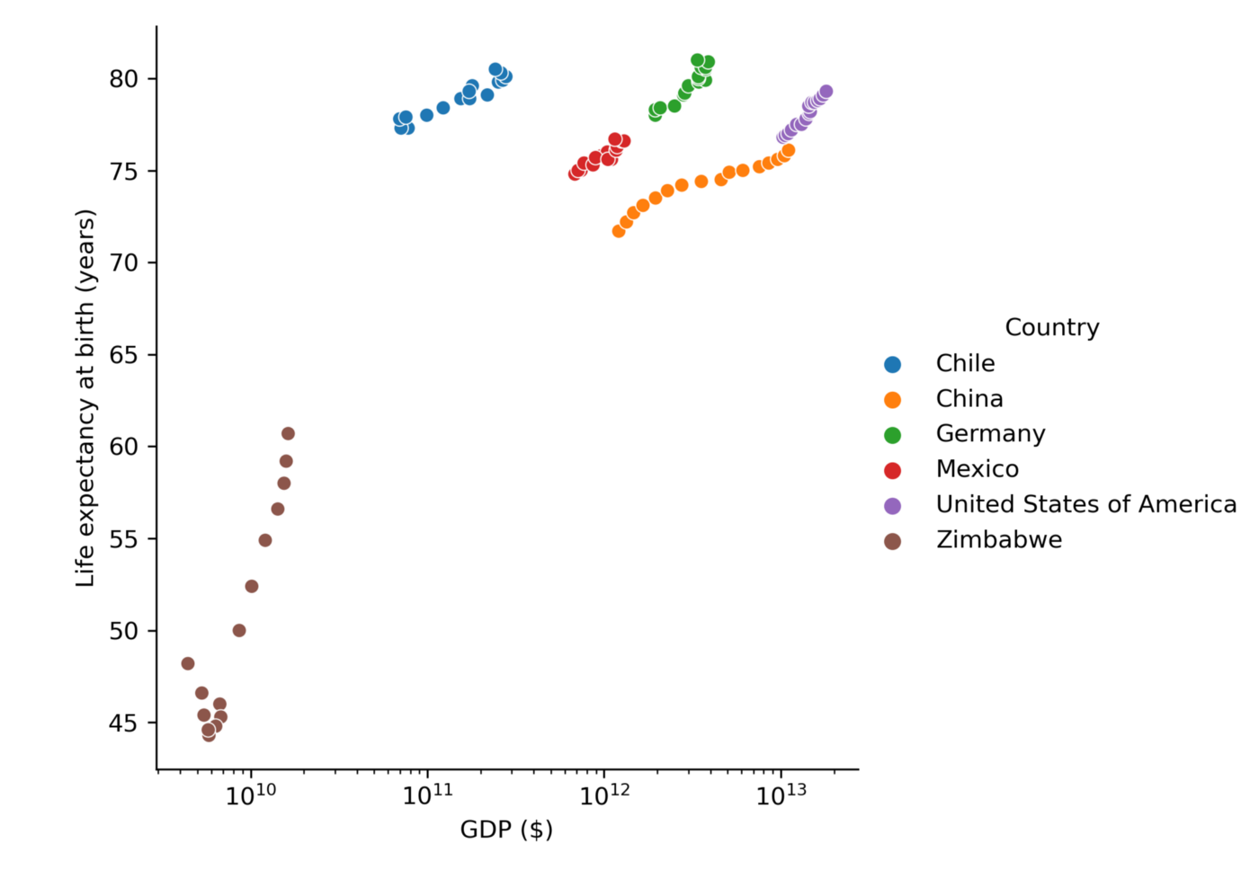

Data Source: WHO and World Bank

Here we go. It’s clear each country shows progress up and to the right. And as we saw before there is a difference between countries. Zimbabwe shows the most rapid trend upward while Chile has the shallowest positive trend of the group. Each country seems to follow its own ‘track’ shifted horizontally or vertically relative to the others. Which makes sense as each country should have its own idiosyncratic characteristics and we are only concerned with one variable(gdp)

**Conclusion**

1. Wealth is likely linked to the average life expectancy of a country. But, this relationship will vary between countries. It might be one factor but its not the only factor and perhaps not even the most important one when determining the life expectancy relative to other countries
2. Within a country, the trend of average life expectancy and a country’s GDP show a strong correlation. Suggesting the possibility that rising GDP and rising life expectancy are linked.

**More to explore**

There is good reason to believe that wealth plays a factor in life expectancy. It makes sense. Wealth can stand in for better resources to access a healthier diet, cleaner water, and advanced medical care among other things. The measure I used, GDP, is crude but easily found. What would be more useful is a measure that could apply between countries. Some possible better measures for this:

* GDP/per capita (country wealth divided by the number of people in the country)
* Median net worth
* Median income

On a tangent to this, I find the possibility that within countries a division between rich and poor might result in different trends in life expectancy. For instance, does the life expectancy of the poor change at a different rate than the rich? Does the rising tide of gdp ‘lift all boats’ equally?

This is my first post. Feel free to comment and let me know what you think.

The code I used can be found [here](https://github.com/StarkArk/Life-Expectancy-and-GDP-CodeCademy-Project/blob/main/life-expectancy-gdp-analysis.ipynb).